1. Use array of all English chars

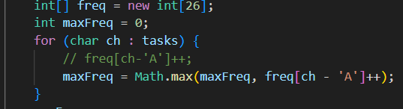

<https://leetcode.com/problems/task-scheduler/description/>

1. Using the priority queue when need to get not only the max/min but also the others

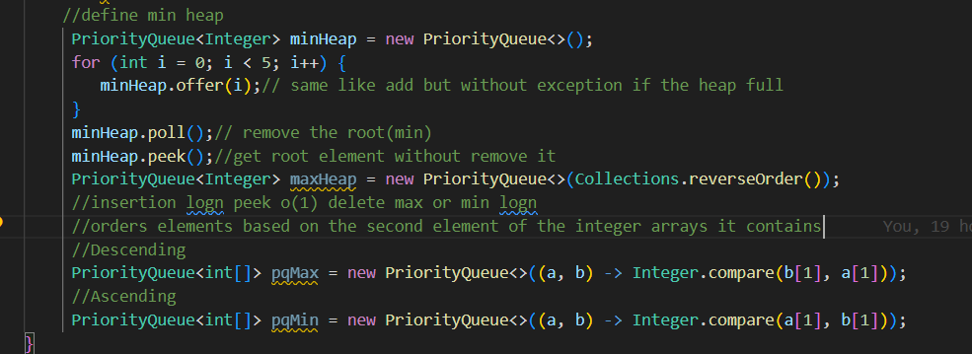

<https://leetcode.com/problems/reorganize-string/>

1. Backtracking: to find all the permutations  
   https://leetcode.com/problems/word-break/description/  
   https://www.youtube.com/watch?v=QgLKdluDo08&ab_channel=NeetCodeIO   
   https://leetcode.com/problems/word-break-ii/  
   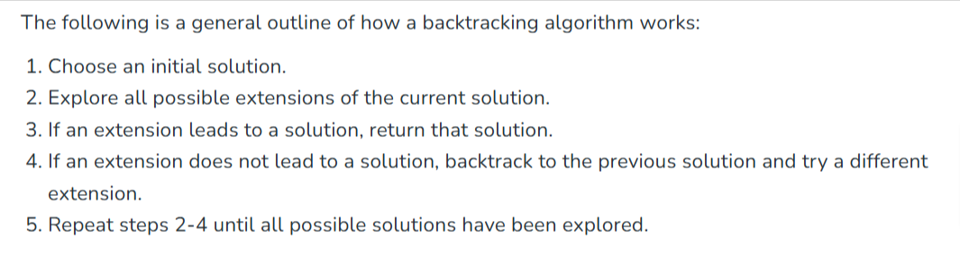
2. You can convert the tree to graph by have map<node,node> to hold each node and it’s parent so you can use left and right and parent and use list for visited to have unidirectional not bidirectional  
   <https://leetcode.com/problems/all-nodes-distance-k-in-binary-tree/>